**KALLAM HARANADHAREDDY INSTITUTE OF TECHNOLOGY  
(AUTONOMOUS)**

**A CRM APPLICATION TO ENGINEERING WORK**

**By**

**VALLAPU NANDINI**

[**228x5a4211@khitguntur.ac.in**](mailto:228x5a4211@khitguntur.ac.in)

**VISSAMSETTY PAVAN KUMAR**

[**218x1a42b0@khitguntur.ac.in**](mailto:218x1a42b0@khitguntur.ac.in)

**SHAIK VENKATESH**

[**218x1a4296@khitguntur.ac.in**](mailto:218x1a4296@khitguntur.ac.in)

**VARIKALLU NAGA BABU**

[**218x1a42a7@khitguntur.ac.in**](mailto:218x1a42a7@khitguntur.ac.in)

**Project Abstract**

This project focuses on developing a CRM application designed to manage client information for engineering projects. The application will store and organize essential details such as company information, owner and contact details, worker profiles, and their material requirements, including specific measurements. It will automatically calculate costs based on these material specifications.

The application will support various engineering works, including Fabrication, Shed Construction, and Pipe Lining. Within the Fabrication work, it will track processes like Drilling, Welding, Cutting, and Folding. For Shed Construction, it will manage the planning and building of sheds, and for Pipe Lining, it will handle tasks related to pipe repairs and replacements.

By efficiently tracking and managing these workflows, the application will help ensure accurate project delivery, improve organization, and streamline cost calculations, making it easier for engineering companies to handle their projects from start to finish.

**Introduction**

The Engineering Works CRM Application is designed to help engineering companies efficiently manage client information and project workflows. It will store essential details such as client company information, owner and contact details, worker profiles, and material requirements with accurate measurements. The application will also automatically calculate prices based on the materials used.

It will support various engineering services, including Fabrication (Drilling, Welding, Cutting, and Folding), Shed Construction, and Pipe Lining (repairing and replacing pipes). By automating these processes and organizing data, the application aims to streamline project management, enhance accuracy, and improve efficiency, ultimately helping engineering companies deliver quality services to their clients.

**Objectives**

1. Efficiently manage client, project, and worker information for engineering tasks.
2. Automate material and cost calculations based on project requirements.
3. Track and monitor the progress of engineering tasks in real time.
4. Streamline labour and material management across fabrication, shed construction, and pipe lining.
5. Generate detailed reports and invoices for clients with accurate cost breakdowns.
6. Enhance project collaboration through user roles and access management.
7. Provide real-time updates and notifications on project status and resource usage.

**Salesforce Key Features and Concepts Utilized**

1. **Org Creation:** Setup a Salesforce Org as the foundation for project management.
2. **Objects:** Use standard (Accounts, Contacts) and custom objects (Projects, Workers, Materials, Tasks).
3. **Tabs:** Create custom tabs for easy navigation between Projects, Workers, Materials, and Tasks.
4. **Lightning App Builder:** Customize user interfaces and apps for different roles.
5. **Fields:** Add custom fields to capture project-specific data (e.g., material quantities, task hours).
6. **Page Layouts:** Design custom layouts for each object type to display key information effectively.
7. **Record Types:** Define different business processes for various types of projects and tasks.
8. **Validation Rules:** Ensure data quality by setting rules for budgets, material quantities, and task duration.
9. **Email Templates:** Automate communication with clients and workers through pre-defined templates.

10.**Flows**: Automate critical processes like task assignments, material orders, and cost calculations using Salesforce Flows.

**Detailed Steps to Solution Design**

**Salesforce developer account creation:**

* **Creating Developer Account:**

Creating a developer org in salesforce.

1. Go to <https://developer.salesforce.com/signup>
2. On the sign up form, enter the following details:

* First name : Vallapu
* Last name : Nandini
* Email : vallapunandini03@gmail.com
* Role: Developer
* Company: KHIT
* County: India
* Postal Code: 522034

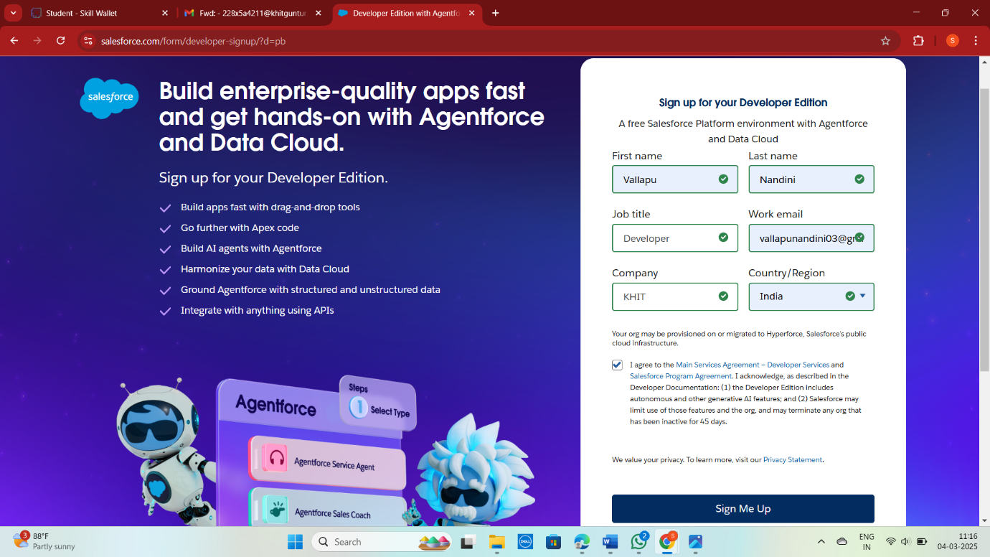

* Username: [engineeringworks@nandiniteam.com](mailto:engineeringworks@nandiniteam.com)

**Account Activation :**

After creating your Salesforce Developer Account, you need to activate it. Follow these steps to activate your account:

**Check Your Email**

Go to the inbox of the email address you used while signing up. The verification email may take 5-10 minutes to arrive.

**Verify Your Account**

* Open the email from Salesforce and click on the "Verify Account" link.
* On the verification page, create a password for your account.
* Answer a security question for account recovery.
* Click on "Change Password".

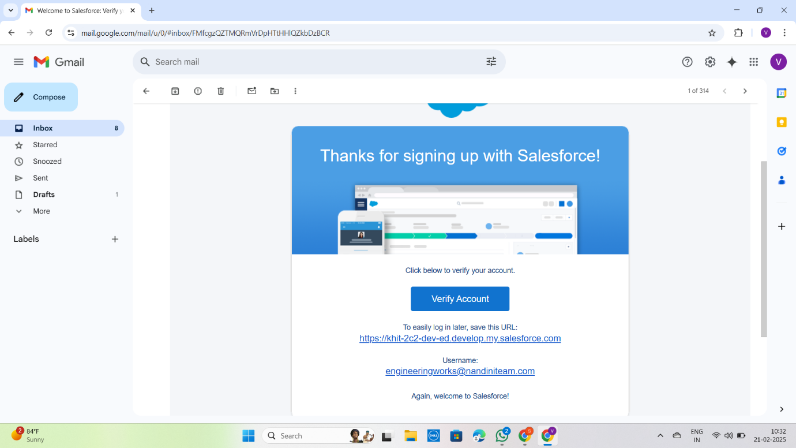

**Object :**

To Navigate to Setup page:

To create an object:

1. From the setup page ? Click on Object Manager ? Click on Create ? Click on Custom Object.
2. On Custom object defining page:
3. Enter the label name, plural label name, click on Allow reports, Allow search.
4. Click on Save.

**Create Fabrication Object:**

To create an object:

1. From the setup page ,Click on Object Manager , Click on Create ,Click on Custom Object.
2. Enter the label name: Fabrication
3. Plural label name :Fabrications
4. Enter Record Name Label and Format

* Record Name : Fabrication Name
* Data Type :Text
* Click on Allow reports and Track Field History, Allow Activities
* Allow search ,Save.
* We Follow The Same Process For Remaining Objects Such As : **Shed-Work Object , Pipe Lining Object , Worker Object.**

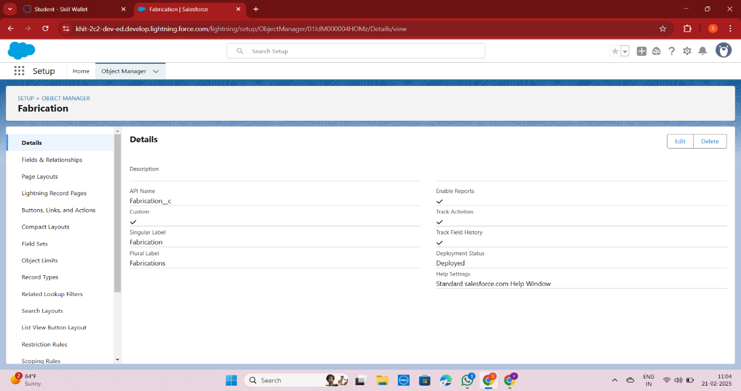

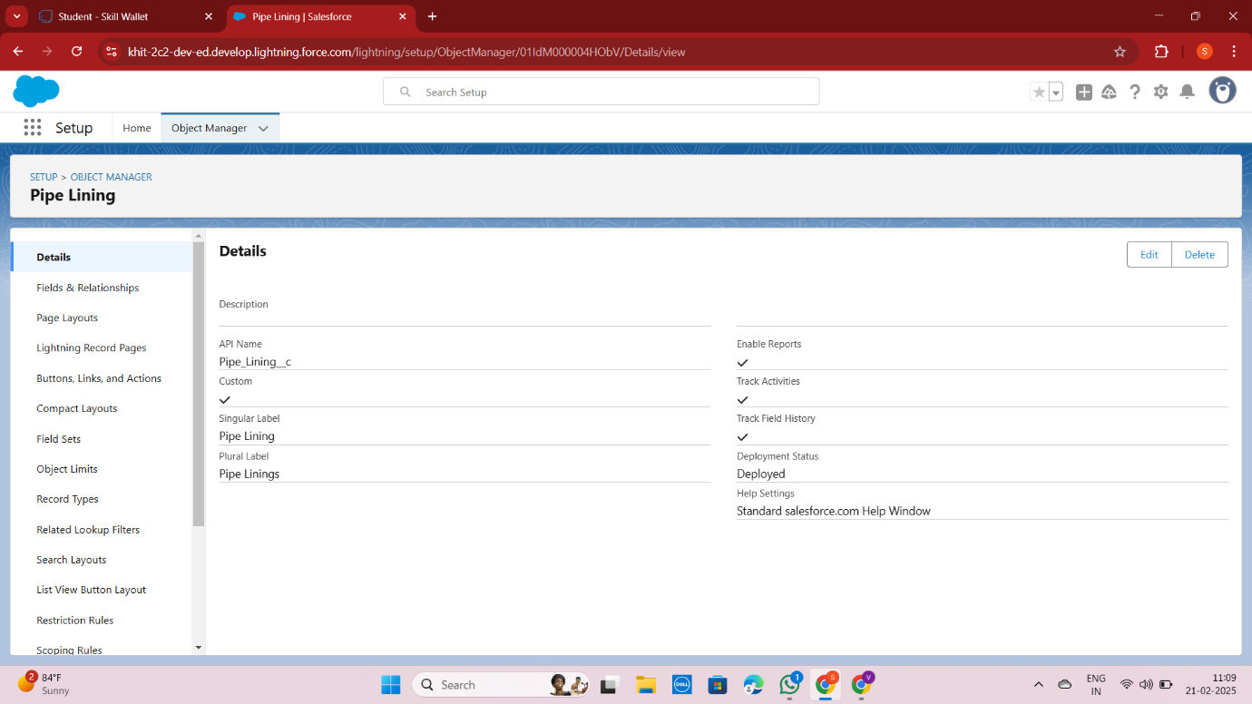

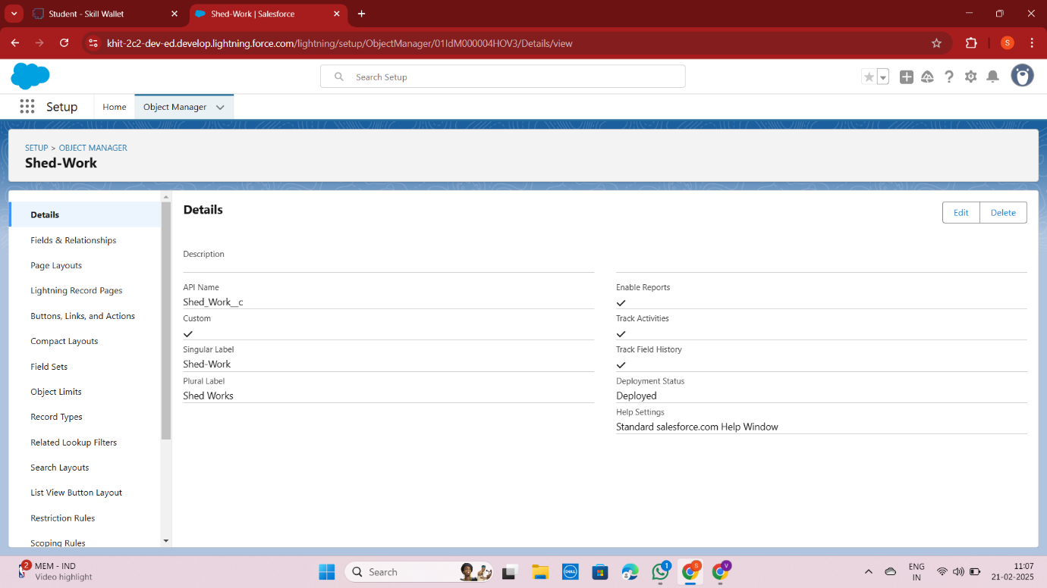

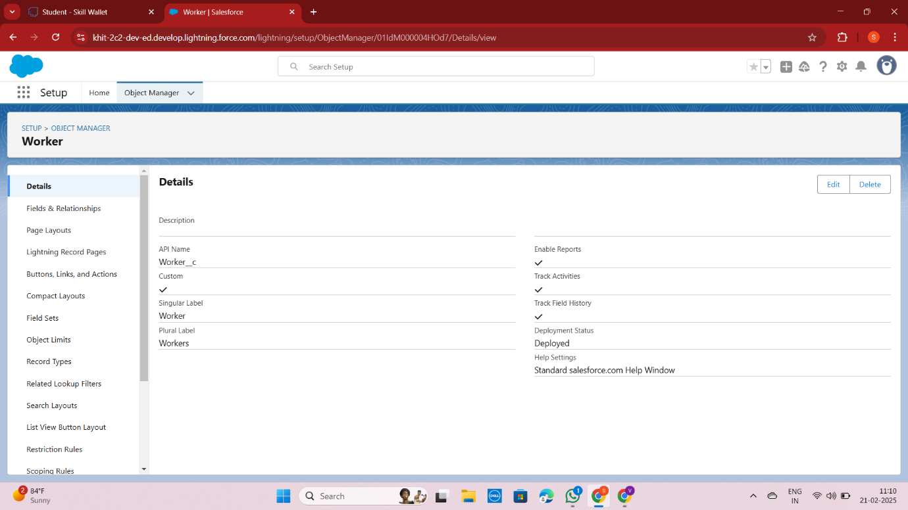

**Tabs :**

What is Tab : A tab is like a user interface that is used to build records for objects and to view the records in the objects.

**Creating a Custom Tab :**

To create a Tab:( Fabrication)

1. Go to setup page , type Tabs in Quick Find bar , click on tabs , New (under custom object tab)
2. Select Object(Fabrication) ,Select the tab style , Next (Add to profiles page) keep it as default , Next (Add to Custom App)  uncheck the include tab .
3. Make sure that the Append tab to users' existing personal customizations is checked.
4. Click save

* Now create the Tabs for the remaining Objects, they are “**Shed-Work, Pipe lining, Worker**”.

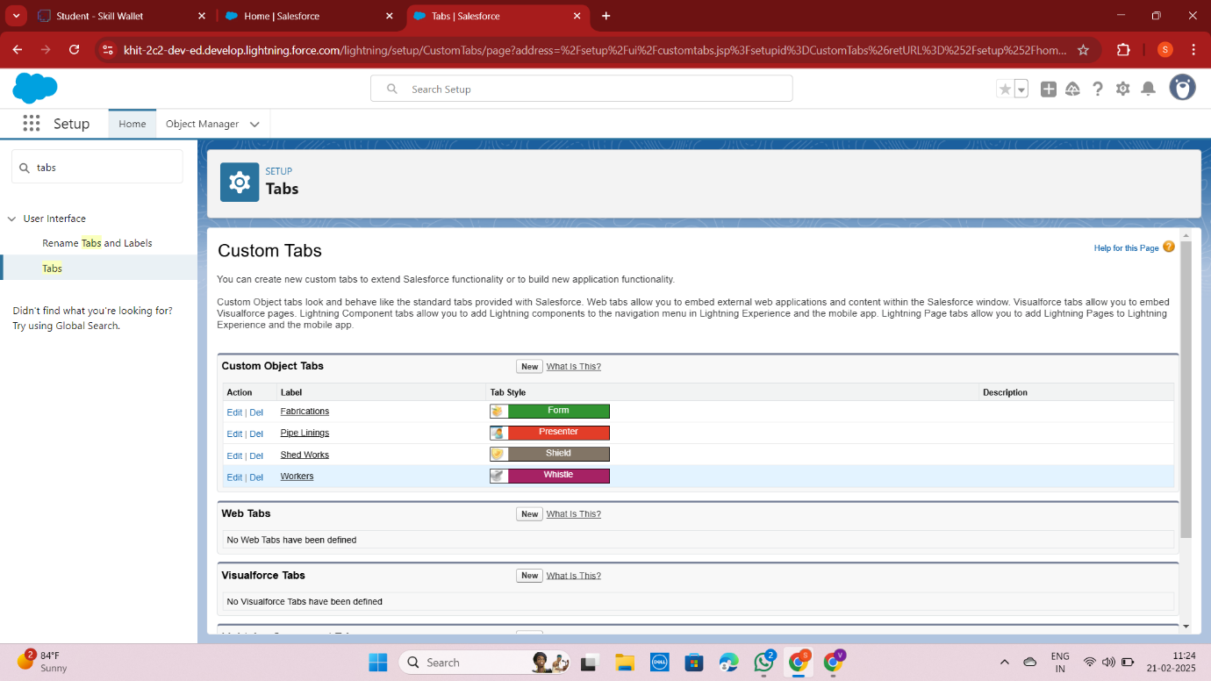

**The Lightning App :**

**Create a Lightning App :**

1. **Access App Manager:**

* Go to the Setup page in Salesforce.
* In the Quick Find box, search for "App Manager" and select it.
* Click on "New Lightning App" to start creating your app.

1. **App Details and Branding:**

* App Name: Enter "Engineering Works".
* Developer Name: This will auto-populate.
* Image: Optional; you can add an image if desired.
* Primary Color Hex Value: Keep the default setting.

1. **App Options Page:**

* Set the Navigation Style to "Standard Navigation".
* Click "Next".

1. **Utility Items:**

* Keep the default settings.
* Click "Next".

1. **Add Navigation Items:**

* Search for items like "Fabrications", "Shed Works", "Pipe Linings", and "Workers" in the search bar.
* Use the arrow button to move these items to the selected list.
* Click "Next" twice.

1. **Add User Profiles:**

* Search for the "System Administrator" profile in the search bar.
* Click on the arrow button to add it to the selected profiles list.
* Click "Save & Finish".

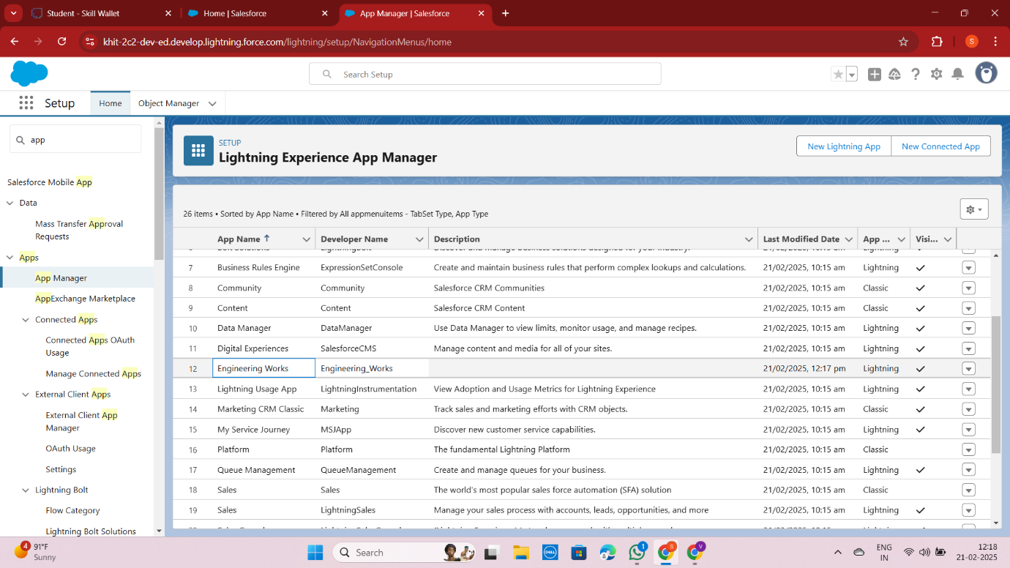

**Fields :**

* **Creation of fields for the Fabrication object :**

To create fields in an object:

1. Go to setup , click on Object Manager , type object name(Fabrication) in search bar , click on the object.
2. Now click on “Fields & Relationships”, New
3. Select Data Type as a “Text”
4. Click on next

Fill the Above as following:

1. Field Label: Name of the Owner
2. Field Name : Name_of_the_Owner
3. Length : 125
4. Required :check box & Save

We created the following fields for the Fabrication object in Salesforce:

| **Field Label** | **Field Name** | **Data Type** | **Required** | **Default Value** | **Description** |
| --- | --- | --- | --- | --- | --- |
| Name of the Owner | Name_of_the_Owner | Text | Yes | - | Owner's name |
| Name of Company | Name_of_Company | Text | No | - | Company name |
| Length | Length | Number | Yes | - | Length of fabrication object |
| Breadth | Breadth | Number | Yes | - | Breadth of fabrication object |
| Width | Width | Number | Yes | - | Width of fabrication object |
| Area | Area | Formula | No | - | Calculated area (Length * Breadth * Width) |
| Cost per Meter | Cost_per_meter | Number | No | 2 | Cost per meter, read-only |
| Quantity | Quantity | Number | Yes | - | Quantity of fabrication object |
| Amount | Amount | Formula | No | - | Calculated amount (Area * Cost per Meter * Quantity) |
| Material Type | Material_Type | Picklist | No | - | Type of material used (Iron, Aluminum, Metal, Wood, Steel) |
| Final Price | Final_Price | Currency | No | - | Final price of fabrication object |
| Email | Email | Email | No | - | Email address for communication |

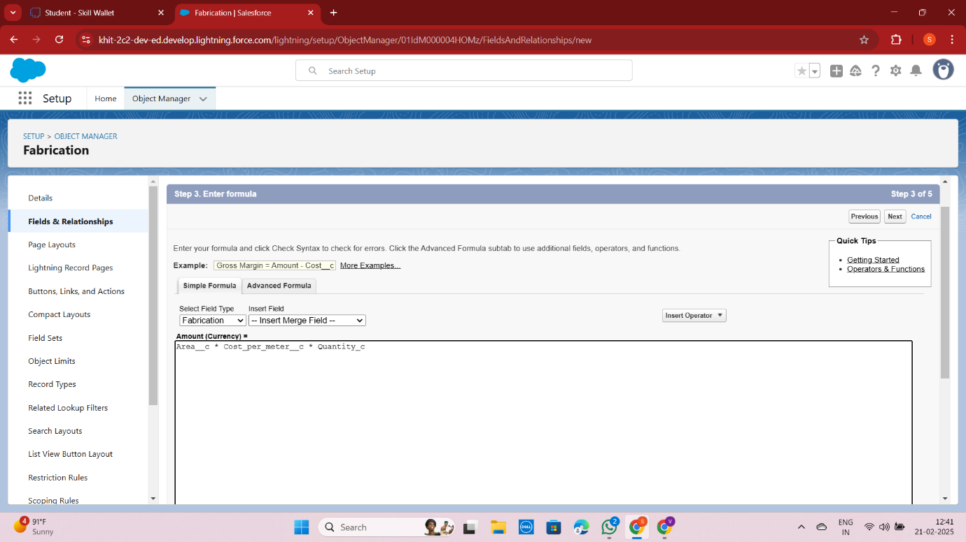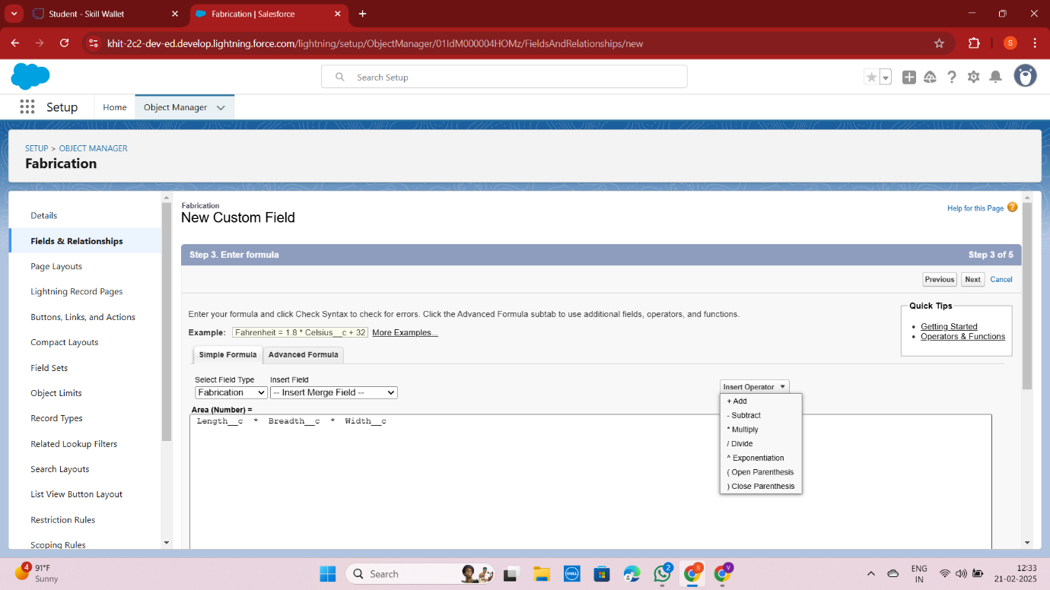

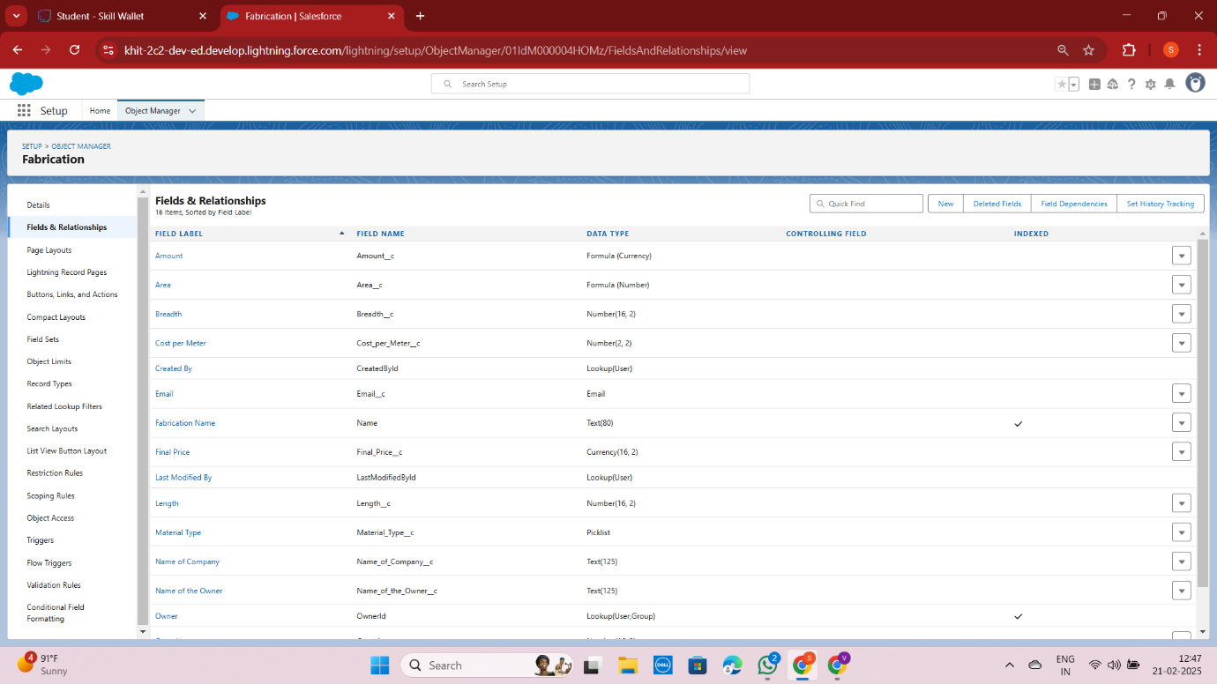

**Creation of fields for the Shed-Work object :**

1. Go to setup ,click on Object Manager , type object name(Shed-Work) in search bar click on the object.
2. Now click on “Fields & Relationships” , New
3. Select Data type as a “Text” and Click on Next
4. Fill the Above as following:

* Field Label : Name of the Company
* Field Name : gets auto generated
* Click on required check box
* Click on Next , Next, Save and new.

We Follow the Same Steps to the Remaining fields in the Shed-Work Object :

The Fields are as follow :

* Name Of the Company
* Name Of the Owner
* Height
* Breadth
* Width
* Area
* Cost per meter
* Area of Sheet
* Cost per meter Sheet
* Quantity
* Amount
* Material Type Sheet
* Final Price

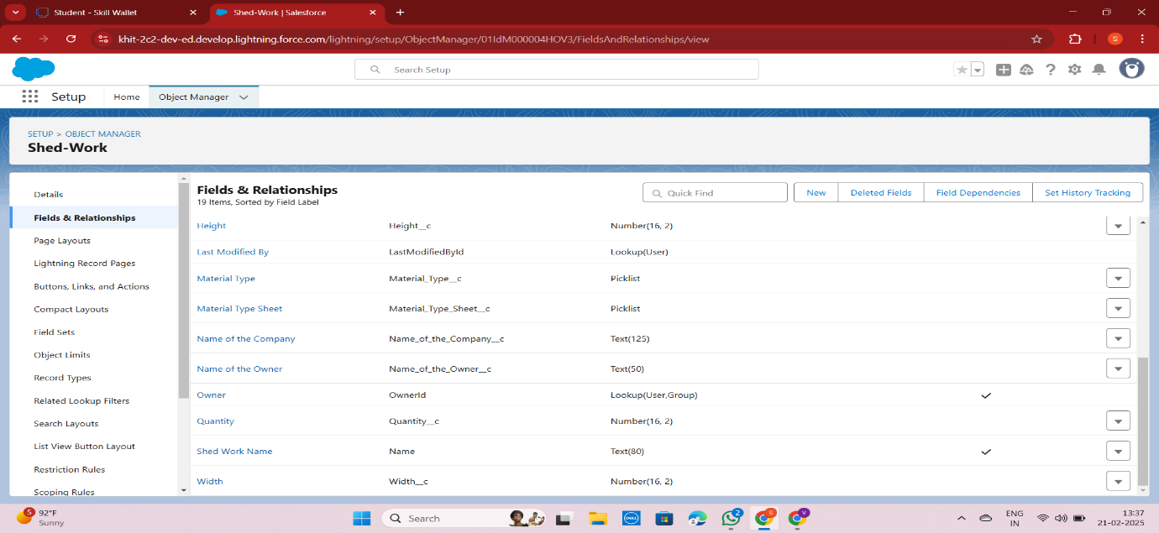

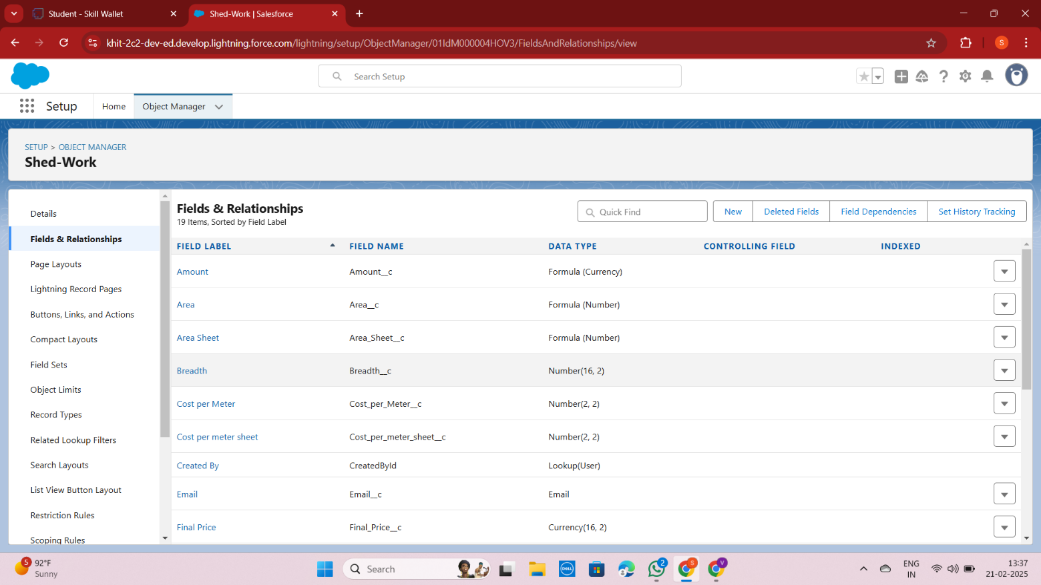

**Creation of fields for the Pipe Lining object**

Go to setup , click on Object Manager, type object name(Pipe Lining) in search bar >> click on the object.

2. Now click on “Fields & Relationships” , New

3. Select Data type as a “Text” and Click on Next

4. Fill the Above as following:

* Field Label : Name of the Company
* Field Name : gets auto generated
* Click on required check box
* Click on Next , Next , Save and new.
* We Follow the Same Steps to the Remaining fields in the Pipe Lining Object :
* The Fields are as follow :
  + - * Name Of the Company
      * Name of the Owner
      * Height
      * Width
      * Diameter
      * Area
      * Cost Per Meter
      * Quantity
      * Amount
      * Material Type
      * Final Price
      * Email.

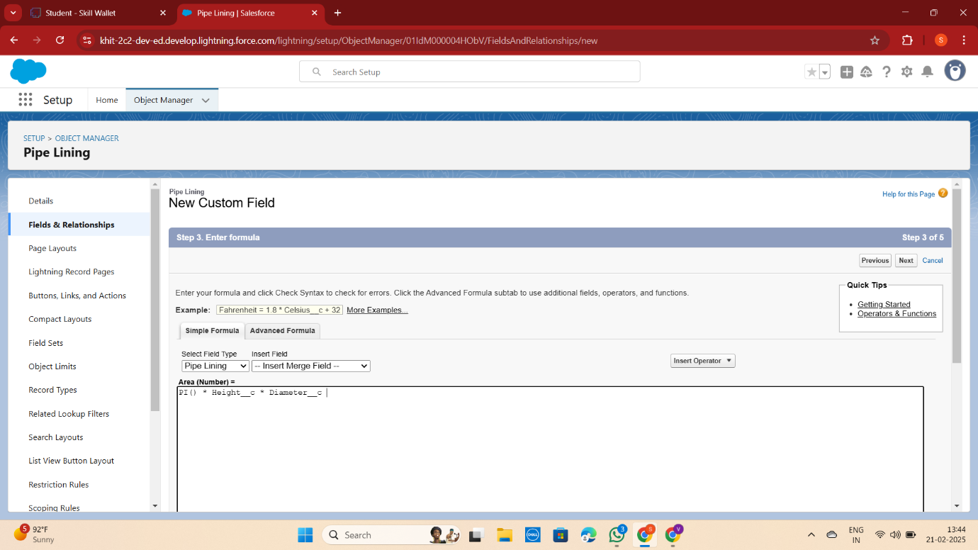

**Creation of fields for the Worker object**

Go to setup, click on Object Manager, type object name(Worker) in search bar , click on the object.

2. Now click on “Fields & Relationships” ,New

3. Select Data type as a “Text” and Click on Next

4. Fill the Above as following:

* Field Label : Worker Name
* Field Name : gets auto generated
* Length : 125
* Click on Next , Next , Save and new.
* We Follow the Same Steps to the Remaining fields in the Worker Object :
* The Fields are as follow :
* Worker Name
* Phone Number
* Designation
* Salary

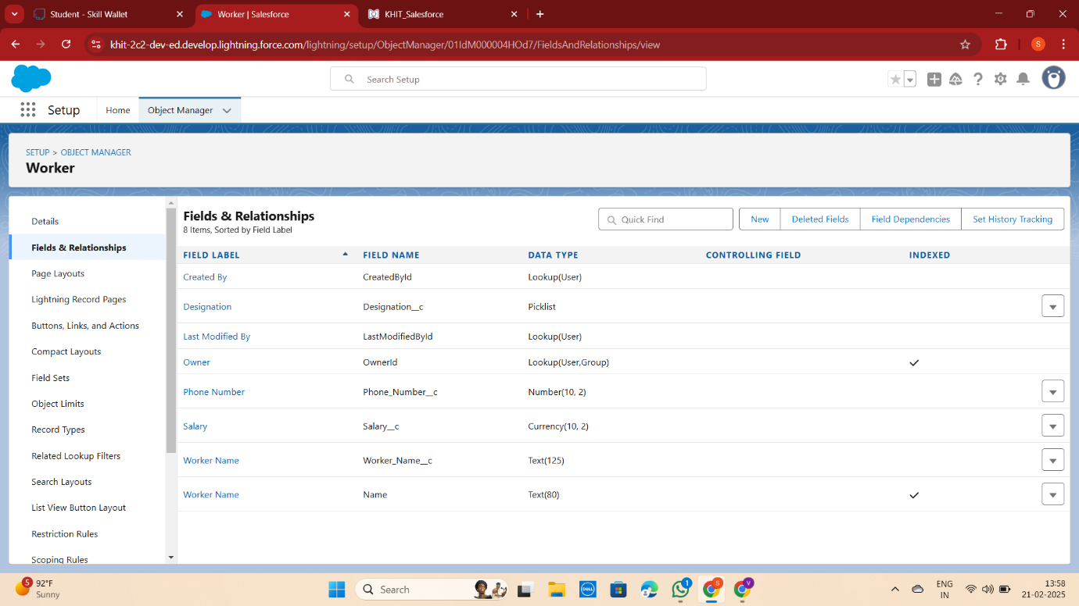

**Creation of Lookup fields**

Creation of Lookup Field on Worker Object :

1. Go to setup, click on Object Manager , type object name(Worker) in the search  bar , click on the object.
2. Now click on “Fields & Relationships” , New
3. Select lookup relationship
4. Select the related object “Fabrication” and click next.
5. Field Name : Fabrication
6. Field label : Auto generated
7. Next , Next ,Save.

* Here we create a Lookup relation , Worker to Remaining Objects Such as **Shed-work, Pipe lining**

### **Creation of Page Layouts :**

The creation of page layouts for drilling, welding, cutting, and folding is a crucial step in organizing and streamlining fabrication processes. Each layout is designed to capture essential information specific to its respective process, ensuring clarity and efficiency in operations. By structuring these layouts effectively, teams can ensure that all critical details are readily available, reducing errors and improving overall productivity.

| **Page Layout Name** | **Fields** |
| --- | --- |
| Drilling Page Layout | Project Name, Date, Drill Bit Size, Material Type, Drill Speed, Feed Rate, Safety Precautions, Procedure Steps |
| Welding Page Layout | Project Name, Date, Weld Type, Material Type, Welding Speed, Shielding Gas, Safety Equipment, Procedure Steps |
| Cutting Page Layout | Project Name, Date, Material Type, Cutting Tool Type, Cutting Speed, Precision Level, Safety Measures, Procedure Steps |
| Folding Page Layout | Project Name, Date, Material Type, Folding Type, Folding Dimensions, Precision Tools Used, Safety Guidelines, Procedure Steps |

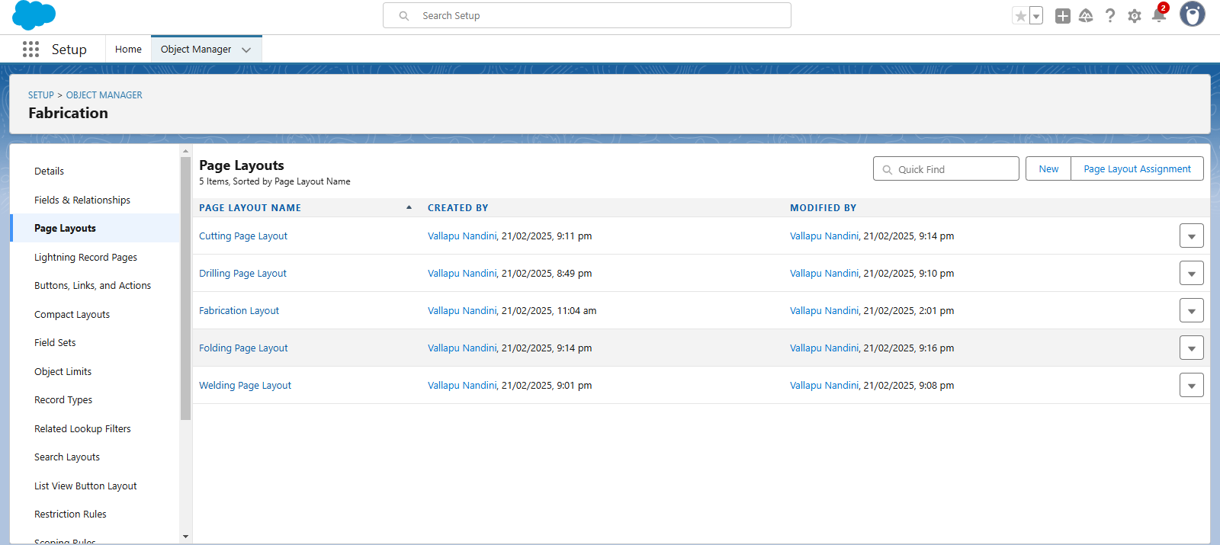

**Creation of Record Types :**

Creating record types for drilling, welding, cutting, and folding is essential for managing fabrication processes effectively. To do this, navigate to the setup page, access the object manager, and edit the Fabrication object. Create a new record type by entering the label and name, and ensure it's active. Then, assign the appropriate page layout—**Drilling, Welding, Cutting, or Folding**—depending on the process. This process is repeated for each record type, resulting in a well-structured system for each fabrication process.

| **Record Type** | **Page Layout** |
| --- | --- |
| Drilling | Drilling Page Layout |
| Welding | Welding Page Layout |
| Cutting | Cutting Page Layout |
| Folding | Folding Page Layout |

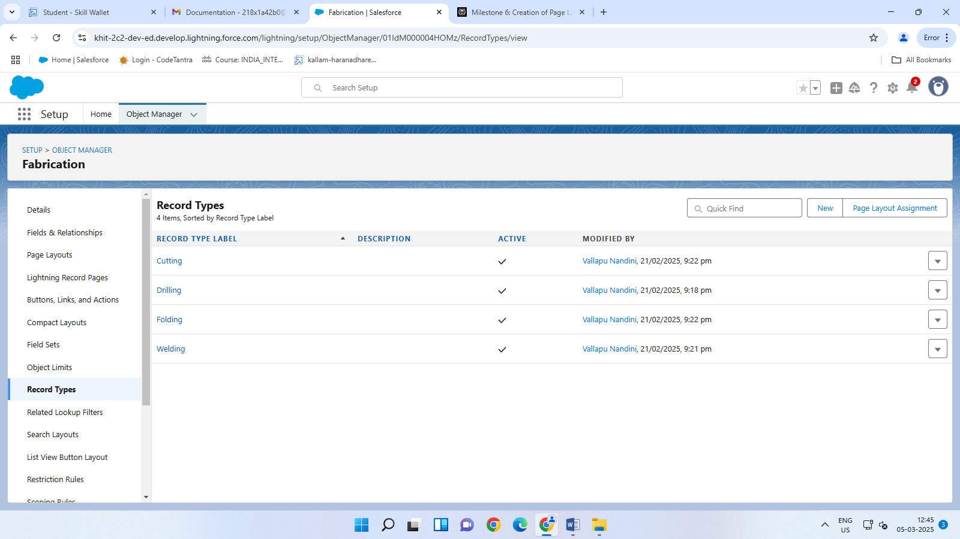

**Validation rule :**

Creating validation rules for fabrication processes is crucial for ensuring data integrity and preventing invalid entries. This involves setting up rules that check for specific conditions and display error messages when those conditions are not met. For the Fabrication Object, a validation rule named "**Rule_for_fabrication**", "**Rule_for_shed_work**"," **Rule_for_pipe_lining**" can be created to ensure that fields like Length, Breadth, Width, and Quantity are not zero. This rule helps maintain consistency and accuracy in fabrication data.

| **Rule Name** | **Error Condition Formula** | **Error Message** |
| --- | --- | --- |
| Rule_for_fabrication | OR(Length__c == 0, Breadth__c == 0, Width__c == 0, Quantity == 0) | Length, Breadth, Width, and Quantity Values should not be zero |
| Rule_for_shed_work | OR( Height__c == 0, Breadth__c == 0, Width__c ==0, Quantity__c == 0) | Height, Breadth, Width and Quantity Values should not be zero |
| Rule_for_pipe_lining | OR( Height__c ==0, Diameter__c ==0, Width__c ==0, Quantity__c == 0) | Height, Diameter, Width and Quantity Values should not be zero |

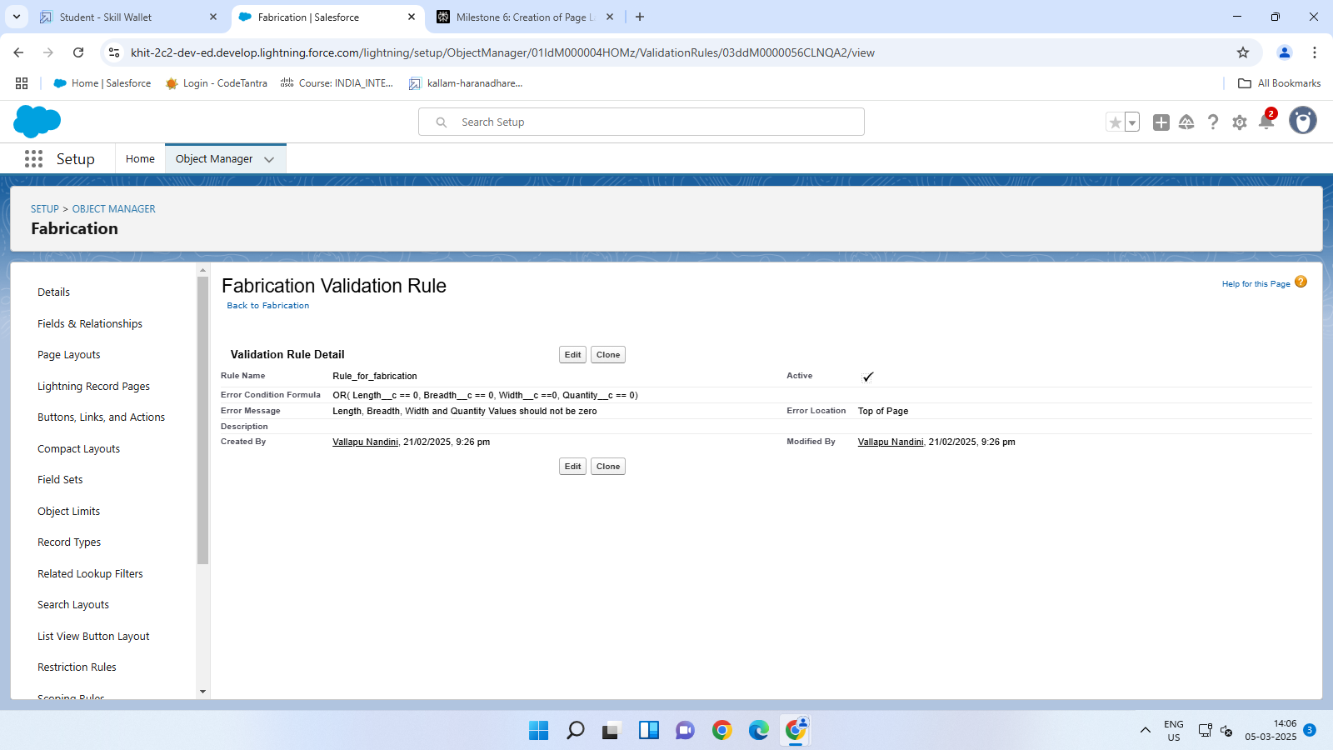

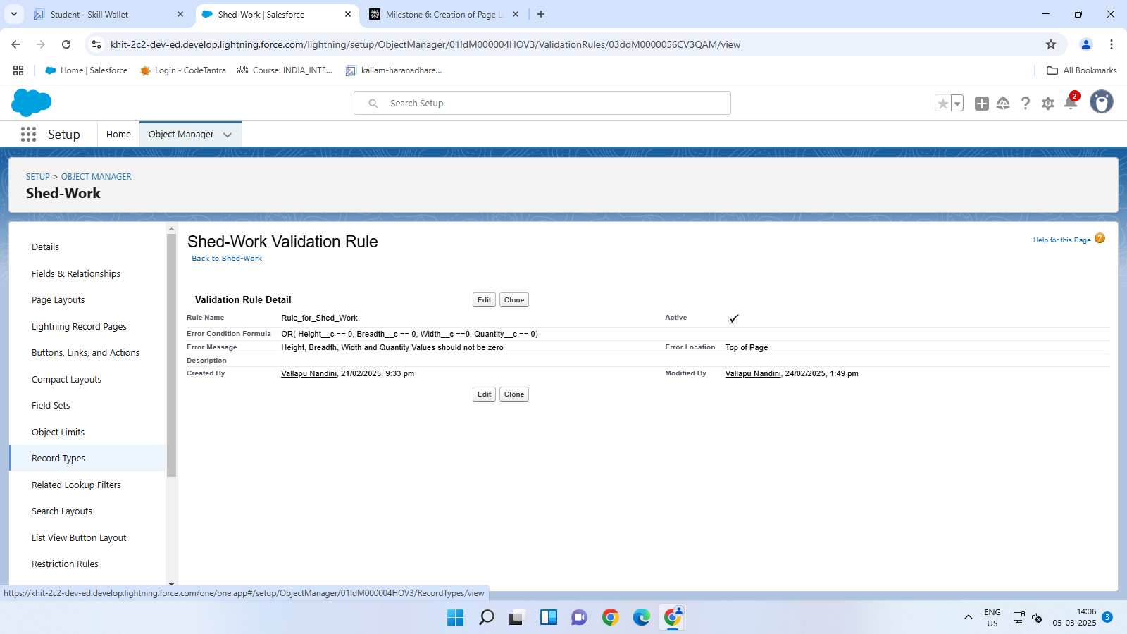

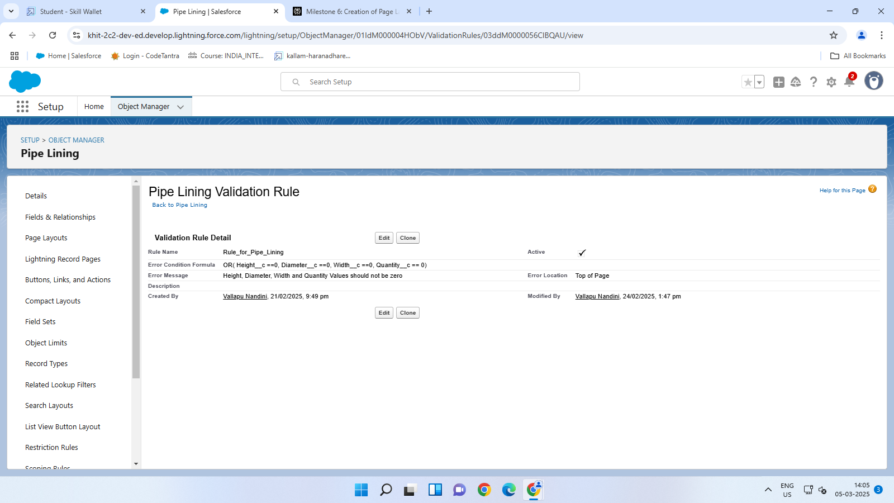

**Email Templates :**

We created email templates in Salesforce by uploading a logo, designing a letterhead, and setting up email templates and alerts for Fabrication, Shed-Work, and Pipe Lining objects. This ensured professional and automated communication across all fabrication processes.

The process began with navigating to the setup page and searching for Email Templates in the quick find box. We then clicked on Classic Email Templates to proceed with creating a new template.

**Email Template Details**

We created a new email template by selecting HTML (using Classic Letterhead) as the type. The template details were as follows:

**Folder:** Unfiled Public Classic Email Templates

**Available for Use:** We checked this box to make the template accessible.

**Email Template Name:** Bill Template

**Template Unique Name:** This was auto-populated by the system.

**Subject:** Fabrication Template

**Email Body**

The email body included the following text:

*Hello {!Fabrication__c.Name_of_the_Owner__c}{!Shed_Work__c.Name_of_the_Owner__c}{!Pipe_Lining__c.Name_of_Owner__c} ,*

*I hope everything is going well in {!Fabrication__c.Name_of_Company__c} {!Shed_Work__c.Name_of_Company__c}{!Pipe_Lining__c.Name_of_Company__c} Company. I have been attached the required items for the work to be done. Please verify them.*

*length = {!Fabrication__c.Length__c}{!Shed_Work__c.Height__c}{!Pipe_Lining__c.Height__c}, breadth = {!Fabrication__c.Length__c}{!Shed_Work__c.Breadth__c}, width = {!Fabrication__c.Width__c}{!Shed_Work__c.Width__c}{!Pipe_Lining__c.Width__c}, area = {!Fabrication__c.Area__c}{!Shed_Work__c.Area__c}{!Pipe_Lining__c.Area__c}, The Final Price = {!Fabrication__c.price__c}{!Shed_Work__c.Price__c}{!Pipe_Lining__c.Price__c*

*Thanks & Regards,*

*Engineering Works.*

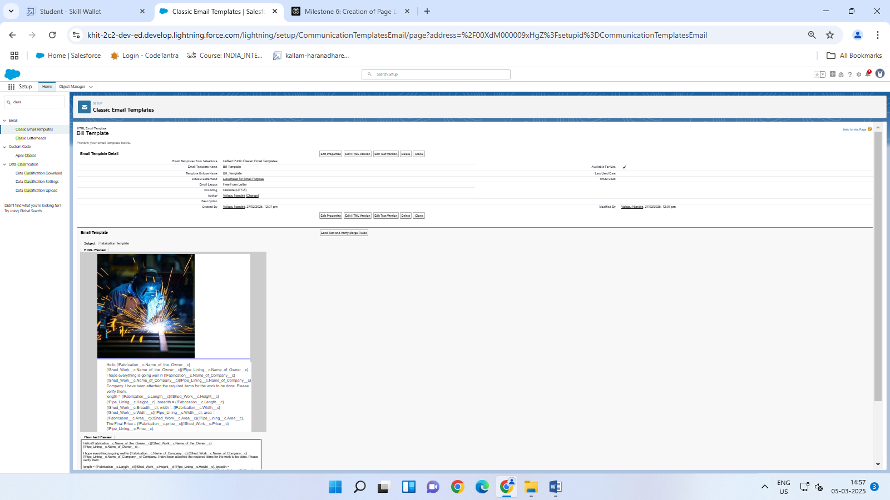

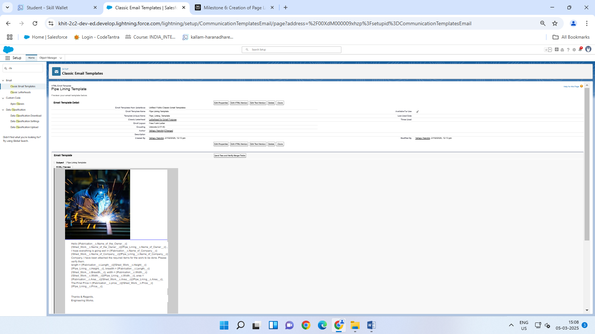

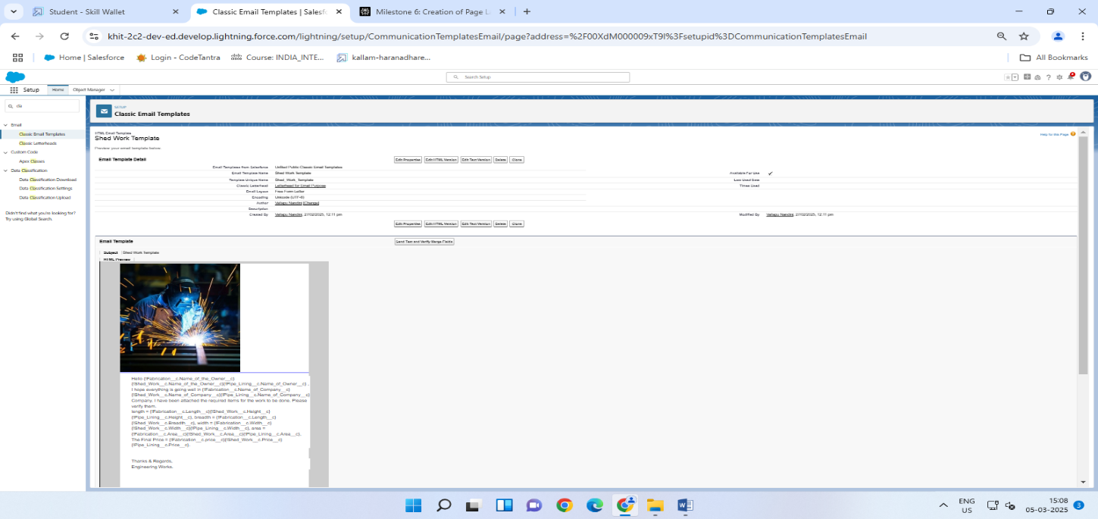

**Flows :**

We created flows in Salesforce to automate the calculation of final prices for **Fabrication, Shed-Work, and Pipe Lining** objects based on material types. Here’s an overview of the process:

* **Fabrication Flow**

1. **Setup Flow:**

* Navigate to Setup, search for Flow, and select New Flow.
* Choose Record-Triggered Flow for the Fabrication object.

1. **Trigger Conditions:**

* Set Entry Conditions to none.
* Trigger the flow when a record is created or updated.

1. **Actions:**

* **Send Email Alert:** Use the Fabrication template.
* **Decision:** Based on Material_Type__c, create outcomes for Iron, Aluminum, Metal, Wood, and Steel.
* **Update Related Record:** For each material type, update the Final_price__c field using a formula based on Amount__c.

Iron: {!$Record.Amount__c} * 2

Aluminum: {!$Record.Amount__c} * 1.8

Metal: {!$Record.Amount__c} * 1.6

Wood: {!$Record.Amount__c} * 1.4

Steel: {!$Record.Amount__c} * 1.2

1. **Save and Activate:**

* Label: Fabrication Flow
* API Name: Fabrication_Flow
* Save and activate the flow.

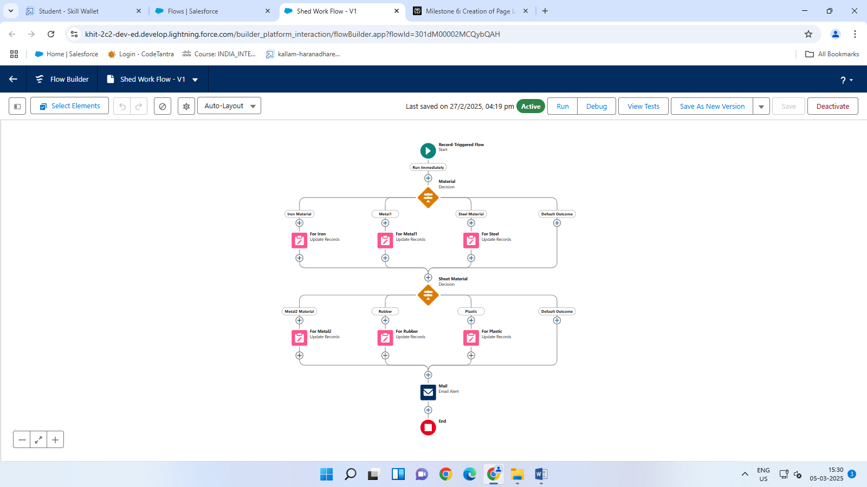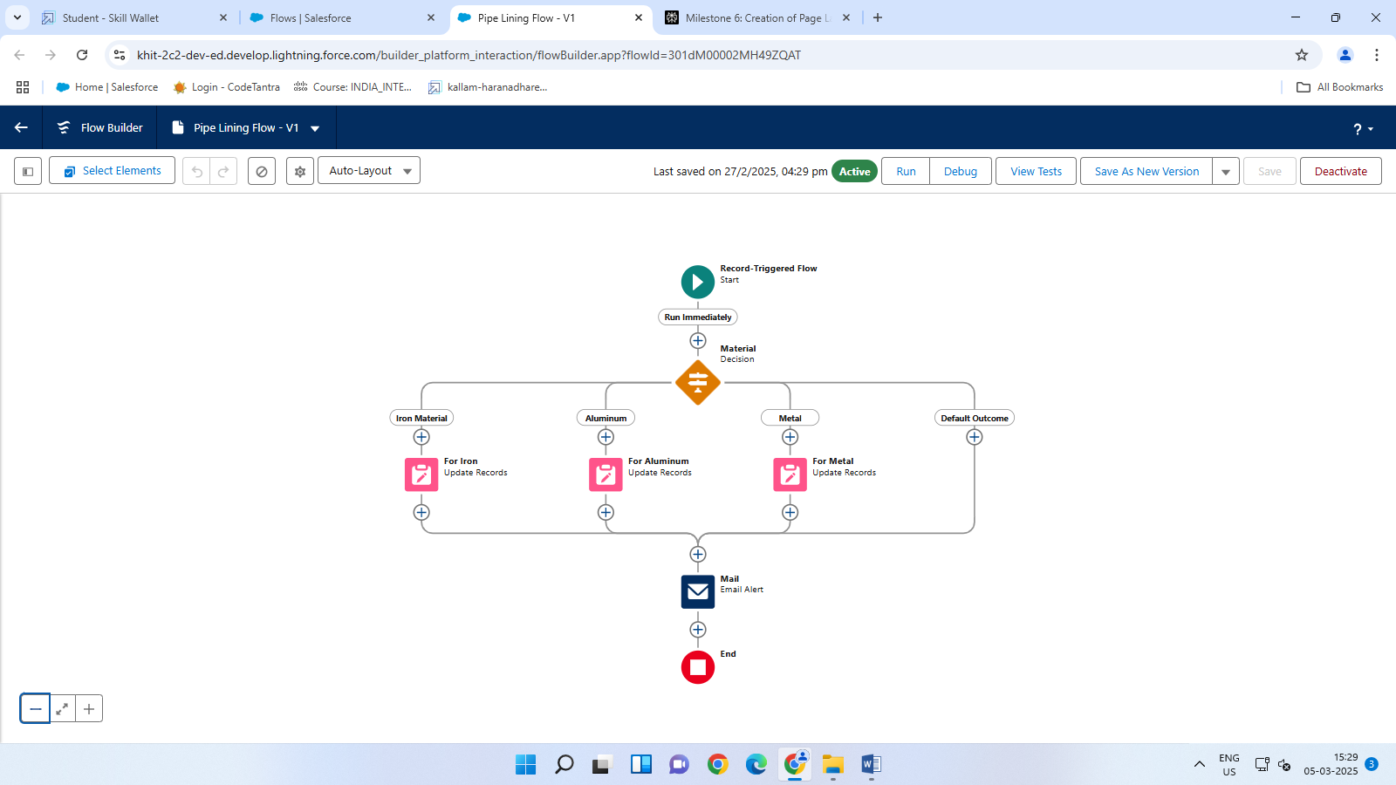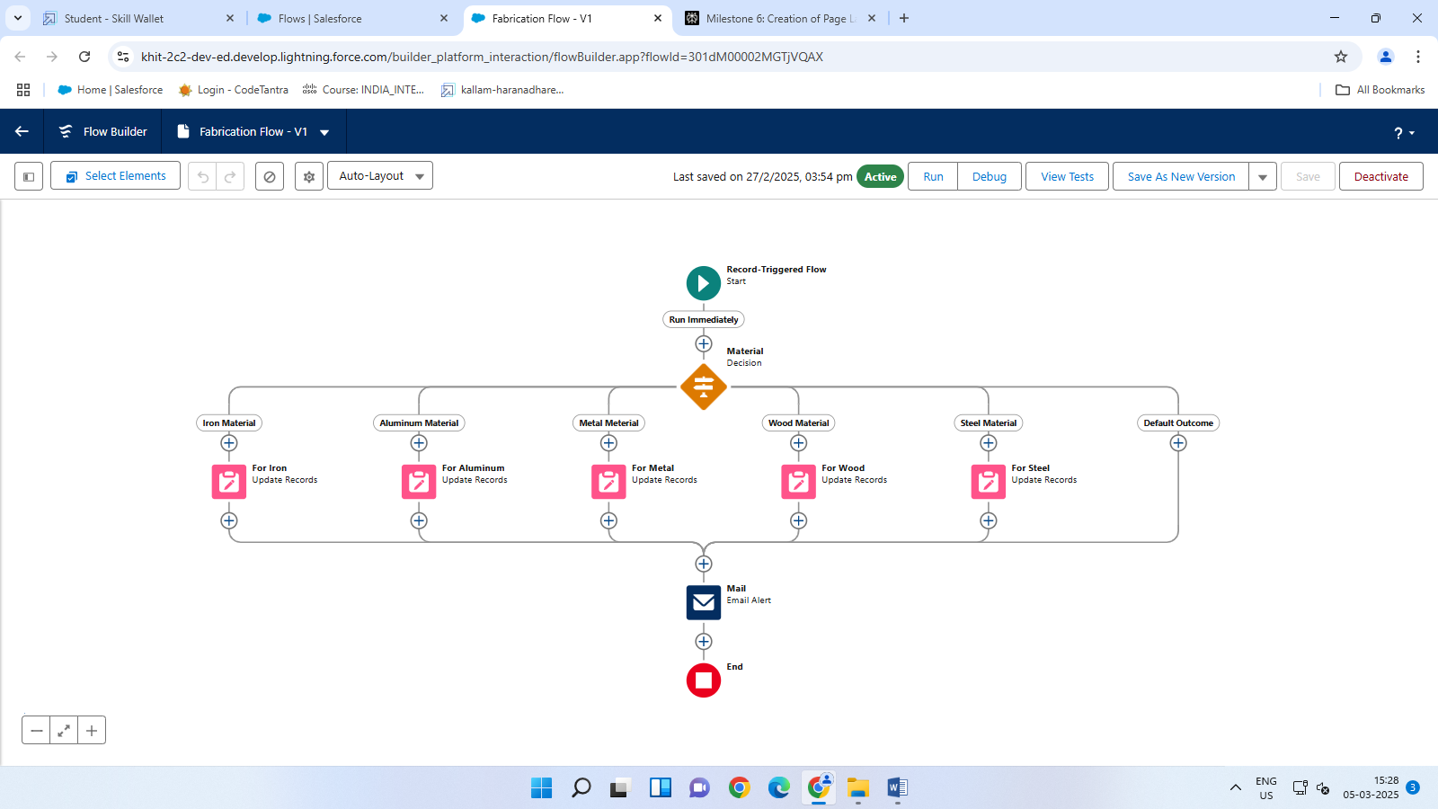

**Outcomes :**

1. **Instant Data Access:**

* Up-to-Date Information: Users can access the latest project data, client interactions, and sales metrics without delays, enabling timely decisions.
* Enhanced Decision-Making: Real-time data helps identify trends, opportunities, and challenges, allowing for proactive strategies.

1. **Improved Collaboration:**

* Unified Team Efforts: All team members have access to the same real-time information, ensuring consistent communication and strategies across departments.
* Enhanced Customer Engagement: Real-time insights help personalize interactions, anticipate customer needs, and provide tailored solutions, improving customer satisfaction.

1. **Dynamic Resource Allocation:**

* Real-Time Tracking: Allows for immediate adjustments in resource allocation based on current project needs, optimizing efficiency and productivity.
* Predictive Analytics: Enables businesses to forecast future trends and customer behavior, making informed decisions to capitalize on opportunities.

1. **Competitive Advantage:**

* Agility and Responsiveness: Real-time data allows businesses to respond quickly to market changes, staying ahead of competitors.
* Innovative Solutions: Adopting real-time CRM capabilities positions the company as a leader in engineering services, enhancing market differentiation

**Conclusion**

The Engineering Works project successfully automates key processes in fabrication, Shed-Work, and Pipe Lining by leveraging Salesforce's capabilities. The system automatically calculates the area of fabrication objects based on parameters such as length, breadth, and width, ensuring accuracy and efficiency. Additionally, the final price is dynamically calculated based on the area and material type, streamlining cost estimation and ensuring that all relevant factors are considered. Custom email templates and alerts are integrated to maintain professional communication and automate notifications to stakeholders.

By achieving these milestones, the project demonstrates a comprehensive approach to automating fabrication processes, enhancing operational efficiency, and improving communication. Validation rules are implemented to enforce data integrity, maintaining data consistency across all fabrication processes. This documentation serves as a guide for future enhancements and implementations, providing a structured framework for ongoing improvements in the Engineering Works project.